# Exercises: Introduction to Databases

This document defines the **exercise assignments** for the ["Databases Basics - MySQL" course @ Software University.](https://softuni.bg/courses/databases-basics-mysql) Install MySQL Community Server. Do not install unneeded features of MySQL Community Server.

## Download and Install MySQL Workbench

Download **MySQL Workbench** from [the official page](https://dev.mysql.com/downloads/workbench/) and **install** it.

## Create New Database

Connect to MySQL Server with user **root** and the password you set up earlier.

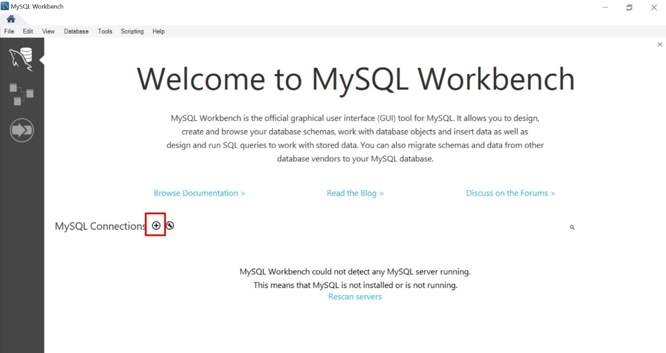

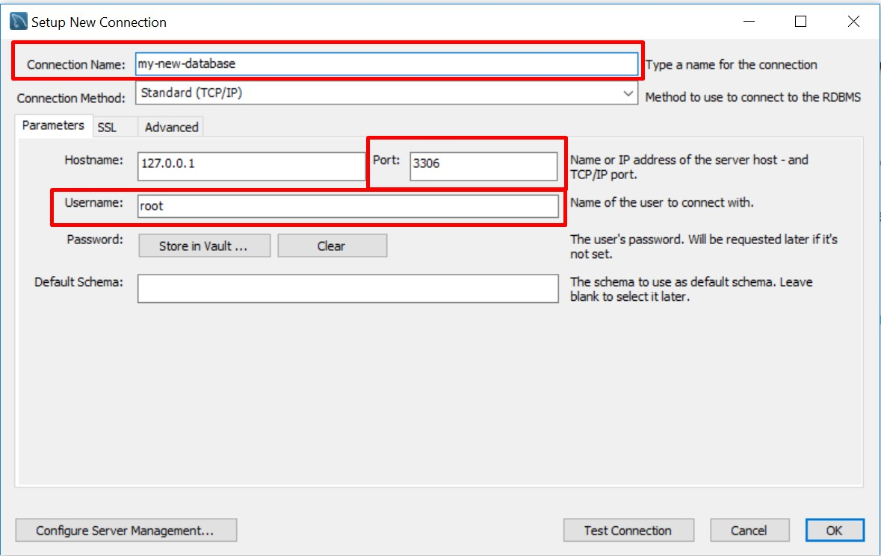

Create new database. Type the name of the database and click OK. This will create your database.

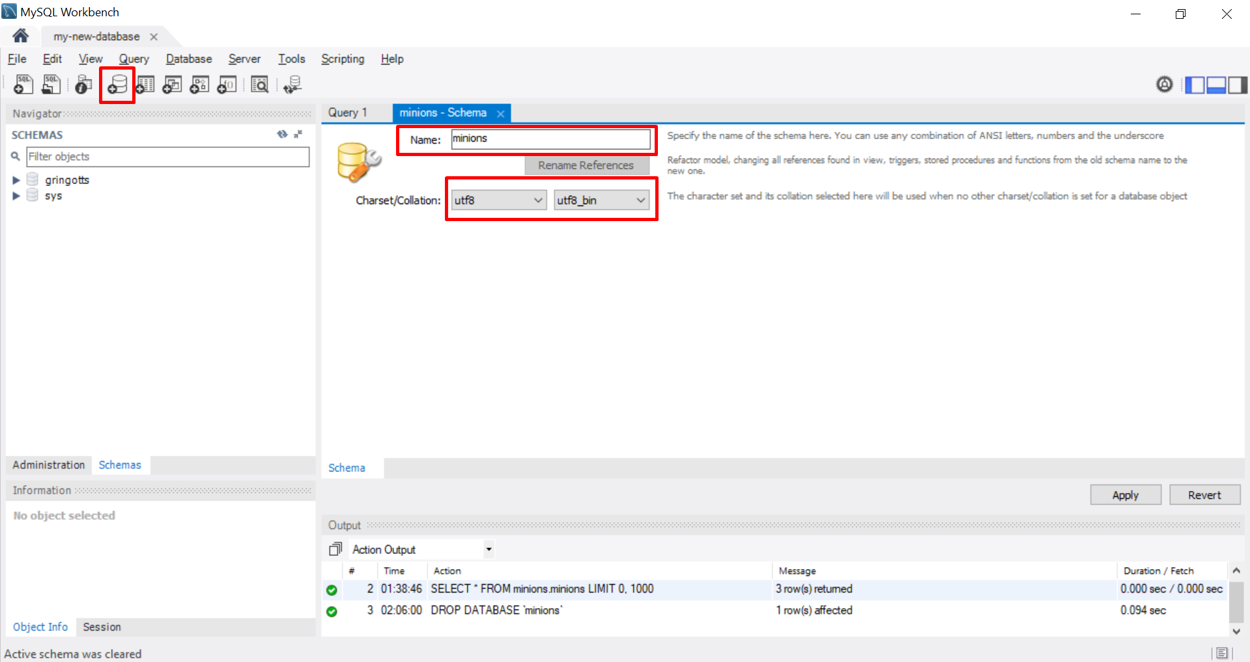

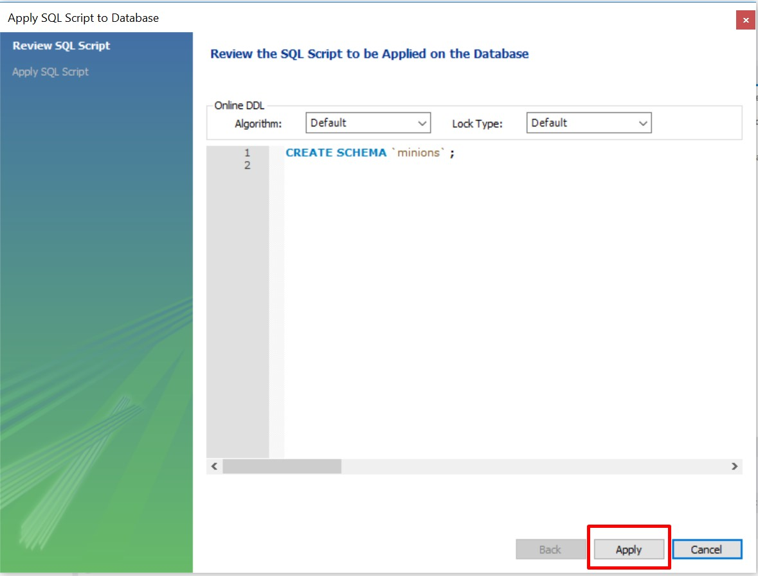

## Create Table

Create **table** **Minions**

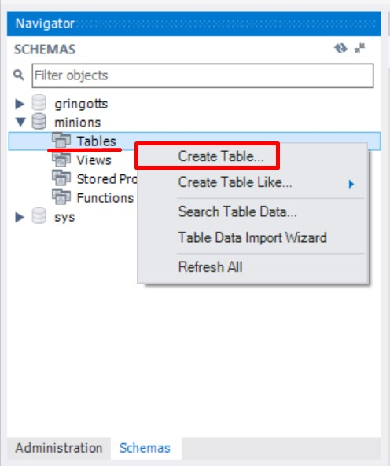

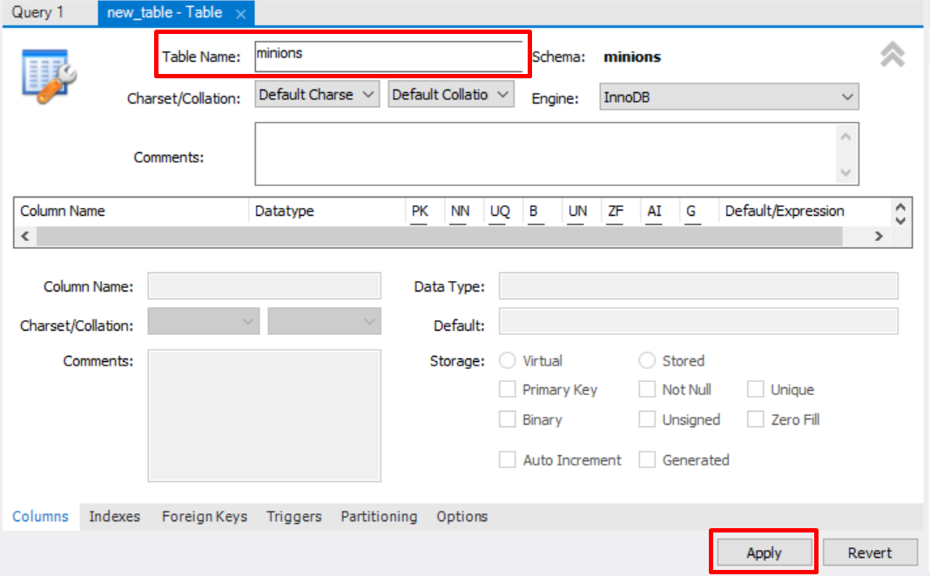

Create columns **id, name, age**. Id and name are **required**; Age should **allow null values**.

Set the **id** as **Primary Key** and **Auto Increment**.

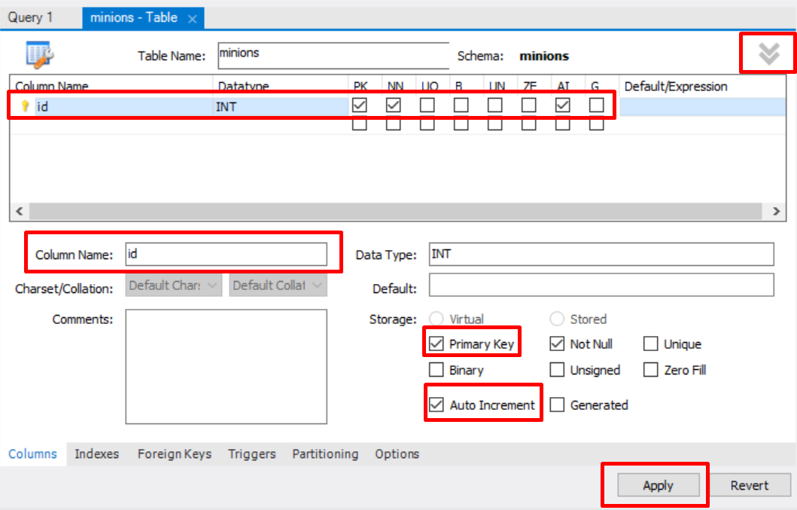

## Insert Data in the Table

Insert data in the table as it’s shown on the picture

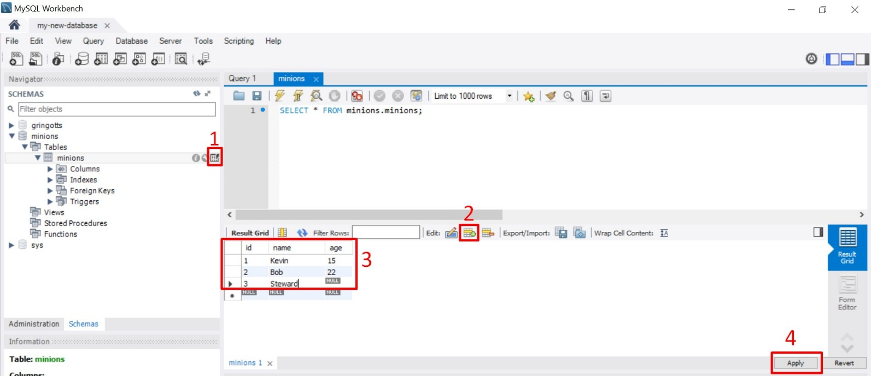

## Select Data from Table

Select **all columns** from the Minions table.

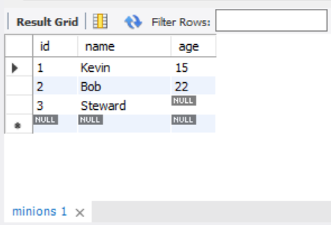

* Open Query tab and write the SQL.
  + Select **only names** from Minions table.
  + **Order** them **ascending by name**

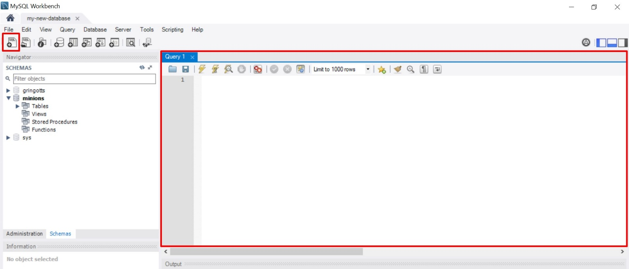

## Update One Record

Change **Stuart’s age** from **NULL** to **10**

## Update All Records

Change all the Minions age to be + 1 years.

## Delete Record

Open Data tab for the table, **right click** on the row where **Bob** is situated and delete it.

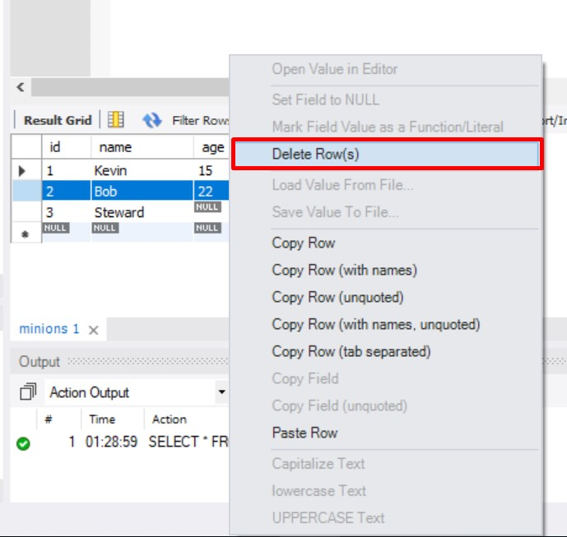

## Create New Table

Create new table **towns**. Every town has **id (int)** and **name (text)**. Make the **id** column **primary key**.

## **Connect Tables

Now let’s make a connection (or relationship) between our two tables. First we need modify our minions table. Add column **town_id** in it **(IMPORTANT: The type of the column must be the same as the type of the column id of the towns table)**.

## Create New Database

Now on your own create a new database **school**. Add a few tables to the database: **students (id, name, age, phone_number)**, **classes (id, name, max_students), teachers(id, name, class)**. Add columns for the tables. Populate the tables with random content. Then delete and make changes in some records.